

KP14603 OBJECT ORIENTED PROGRAMMING

SEMESTER II SESSION 2019/2020

ASSIGNMENT 2

LECTURER: Madam Siti Hasnah Tanalol

CHOW YI LING

BI19110254

**Introduction**

The aim of the COVID-19 Registration System is to make the record of information more convenient by just using this system to record the information. This system also provides some questions about COVID-19 to ensure that whether you had visited or travelled to places that were suspected or confirmed COVID-19 cases. There is also a simple quiz that can learn the general knowledge of COVID-19 and how to prevent it.

The objectives of this assignment are:

1. To gain knowledge about graphical user interface.

2. Learn to develop an efficient registration system.

3. Allow us to build a real program.

**Scope/Proposed works**

1. Basic Information

a. Name

* Name of user

b. Identity Card Number

* IC number of user

c. Mobile Number

* Mobile number of user

d. Body Temperature

* Body temperature of user

2. Safety Question

a. Question 1

* Yes
* No

b. Question 2

* Yes
* No

c. Question 3

* Yes
* No

3. Simple Quiz

a. Quiz 1

* Choice 1
* Choice 2
* Choice 3
* Choice 4

b. Quiz 2

* Choice 1
* Choice 2
* Choice 3
* Choice 4

c. Quiz 3

* Choice 1
* Choice 2
* Choice 3
* Choice 4
* Choice 5

d. Quiz 4

* True
* False

**Scope/Proposed works**

No

Yes

Body temperature of user

IC number of user

Identity Card Number

Question 2

Body Temperature

Mobile number of user

No

Yes

No

Yes

Name of user

Mobile Number

Question 1

Question 3

Name

COVID-19 Registration System

Quiz 4

Quiz 2

False

True

Choice 3e

Choice 1

Quiz 1

Choice 2

Choice 4

Quiz 3

Choice 1

Choice 3

Choice 3

Choice 4

Choice 2

Choice 1

Choice 5

Choice 4

Choice 2

**Java Code**

**BASICINFORMATION.java**

ÏÏÏpackage COVID19REGISTRATION;  
ÏÏÏimport java.awt.event.*;  
ÏÏÏimport javax.swing.*;  
ÏÏÏ  
ÏÕÖ×public class BASICINFORMATION extends JFrame {   
ÏÏ§ÏíÏprivate final JTextField N, I, M, T;  
ÏÏ§ÏíÏprivate final JLabel Name, IC, MN, Temp;  
ÏÏ§ÏíÏprivate final JButton nextB;  
ÏÏ§   
ÏÏ§ÏÞßàBASICINFORMATION () {  
ÏÏ§ÏÏ¨¹íÏJPanel panel= new JPanel();  
ÏÏ§ÏÏ¨¹íÏJFrame myFrame = new JFrame ("Basic Information");   
ÏÏ§ÏÏ¨¹¹ÏmyFrame.setSize (500, 300);   
ÏÏ§ÏÏ¨¹¹ÏmyFrame.setDefaultCloseOperation (JFrame.EXIT_ON_CLOSE);  
ÏÏ§ÏÏ¨¹¹ÏmyFrame.add (panel);  
ÏÏ§ÏÏ§   
ÏÏ§ÏÏ¨¹¹Ïpanel.setLayout (null);   
ÏÏ§ÏÏ§   
ÏÏ§ÏÏ¨¹¹ÏName = new JLabel ("Name: ");  
ÏÏ§ÏÏ¨¹¹ÏName.setBounds (10, 20, 80, 25);  
ÏÏ§ÏÏ¨¹¹Ïpanel.add (Name);  
ÏÏ§ÏÏ¨¹¹ÏN = new JTextField (20);  
ÏÏ§ÏÏ¨¹¹ÏN.setBounds (200, 20, 165, 25);  
ÏÏ§ÏÏ¨¹¹Ïpanel.add (N);  
ÏÏ§ÏÏ§   
ÏÏ§ÏÏ¨¹¹ÏIC = new JLabel ("IC: ");  
ÏÏ§ÏÏ¨¹¹ÏIC.setBounds (10, 50, 80, 25);  
ÏÏ§ÏÏ¨¹¹Ïpanel.add (IC);  
ÏÏ§ÏÏ¨¹¹ÏI = new JTextField (20);  
ÏÏ§ÏÏ¨¹¹ÏI.setBounds (200, 50, 165, 25);  
ÏÏ§ÏÏ¨¹¹Ïpanel.add (I);  
ÏÏ§ÏÏ§   
ÏÏ§ÏÏ¨¹¹ÏMN = new JLabel ("Mobile Number: ");  
ÏÏ§ÏÏ¨¹¹ÏMN.setBounds (10, 80, 100, 25);  
ÏÏ§ÏÏ¨¹¹Ïpanel.add (MN);  
ÏÏ§ÏÏ¨¹¹ÏM = new JTextField (20);  
ÏÏ§ÏÏ¨¹¹ÏM.setBounds (200, 80, 165, 25);  
ÏÏ§ÏÏ¨¹¹Ïpanel.add (M);  
ÏÏ§ÏÏ§   
ÏÏ§ÏÏ¨¹¹ÏTemp = new JLabel ("Body Temperature (C): ");  
ÏÏ§ÏÏ¨¹¹ÏTemp.setBounds (10, 110, 150, 25);  
ÏÏ§ÏÏ¨¹¹Ïpanel.add (Temp);  
ÏÏ§ÏÏ¨¹¹ÏT = new JTextField (20);  
ÏÏ§ÏÏ¨¹¹ÏT.setBounds (200, 110, 165, 25);  
ÏÏ§ÏÏ¨¹¹Ïpanel.add (T);  
ÏÏ§ÏÏ§   
ÏÏ§ÏÏ¨¹¹ÏnextB = new JButton ("Next Page");  
ÏÏ§ÏÏ¨¹¹ÏnextB.setBounds (10, 150, 150, 25);  
ÏÏ§ÏÏ¨¹¹ÏnextB.addActionListener (  
ÏÏ§ÏÏ§ÏÏÏÏÕÖ×new ActionListener(){  
ÏÏ§ÏÏ§ÏÏÏÏÏ§ÏÞßàpublic void actionPerformed (ActionEvent ae) {   
ÏÏ§ÏÏ§ÏÏÏÏÏ§ÏÏ¨¹¹Ïnew SAFETYQUESTION ();  
ÏÏ§ÏÏ§ÏÏÏÏÏ§ÏÏ©}  
ÏÏ§ÏÏ§ÏÏÏÏÏ©});   
ÏÏ§ÏÏ¨¹¹Ïpanel.add (nextB);  
ÏÏ§ÏÏ§  
ÏÏ§ÏÏ¨¹¹ÏmyFrame.setVisible (true);  
ÏÏ§ÏÏ§  
ÏÏ§ÏÏ©}   
ÏÏ©}  
ÏÏÏÏ  
ÏÕÖ×class Information {   
ÏÏ§ÏÞßàpublic static void main (String[] args) throws Exception {  
ÏÏ§ÏÏ¨¹íÏBASICINFORMATION information = new BASICINFORMATION ();  
ÏÏ§ÏÏ©}  
ÏÏ©}  
ÏÏÏ

**SAFETYQUESTION.javaÏ**

Ïpackage COVID19REGISTRATION;  
ÏÏÏimport java.awt.event.*;  
ÏÏÏimport javax.swing.*;  
ÏÏÏ  
ÏÕÖ×public class SAFETYQUESTION extends JFrame {   
ÏÏ§ÏíÏprivate final JLabel S, T, V, risk;  
ÏÏ§ÏíÏprivate JRadioButton yesB1, noB1, yesB2, noB2, yesB3, noB3;  
ÏÏ§ÏíÏprivate final JButton nextB;  
ÏÏ§   
ÏÏ§ÏÞßàSAFETYQUESTION () {   
ÏÏ§ÏÏ¨¹íÏJPanel panel = new JPanel();  
ÏÏ§ÏÏ¨¹íÏJFrame myFrame = new JFrame ("Safety Questions");  
ÏÏ§ÏÏ¨¹¹ÏmyFrame.setSize (800, 300);   
ÏÏ§ÏÏ¨¹¹ÏmyFrame.setDefaultCloseOperation (JFrame.EXIT_ON_CLOSE);  
ÏÏ§ÏÏ¨¹¹ÏmyFrame.add(panel);  
ÏÏ§ÏÏ§   
ÏÏ§ÏÏ¨¹¹Ïpanel.setLayout (null);  
ÏÏ§ÏÏ§   
ÏÏ§ÏÏ¨¹¹ÏS = new JLabel ("1. Do you have any following symptoms? #Fever #Sore throat #Cough #Shortness of breath");  
ÏÏ§ÏÏ¨¹¹ÏS.setBounds (10, 20, 790, 25);  
ÏÏ§ÏÏ¨¹¹Ïpanel.add (S);  
ÏÏ§ÏÏ¨¹¹ÏyesB1 = new JRadioButton ("Yes");  
ÏÏ§ÏÏ¨¹¹ÏyesB1.setBounds (10, 40, 50, 25);  
ÏÏ§ÏÏ¨¹¹Ïpanel.add (yesB1);  
ÏÏ§ÏÏ¨¹¹ÏnoB1 = new JRadioButton ("No");  
ÏÏ§ÏÏ¨¹¹ÏnoB1.setBounds (60, 40, 50, 25);  
ÏÏ§ÏÏ¨¹¹Ïpanel.add (noB1);  
ÏÏ§ÏÏ§   
ÏÏ§ÏÏ¨¹¹ÏT = new JLabel ("2. Have you travelled or resided in any country outside Malaysia in the last 14 days?");  
ÏÏ§ÏÏ¨¹¹ÏT.setBounds (10, 70, 790, 25);  
ÏÏ§ÏÏ¨¹¹Ïpanel.add (T);  
ÏÏ§ÏÏ¨¹¹ÏyesB2 = new JRadioButton ("Yes");  
ÏÏ§ÏÏ¨¹¹ÏyesB2.setBounds (10, 90, 50, 25);  
ÏÏ§ÏÏ¨¹¹Ïpanel.add (yesB2);  
ÏÏ§ÏÏ¨¹¹ÏnoB2 = new JRadioButton ("No");  
ÏÏ§ÏÏ¨¹¹ÏnoB2.setBounds (60, 90, 50, 25);  
ÏÏ§ÏÏ¨¹¹Ïpanel.add (noB2);  
ÏÏ§ÏÏ§   
ÏÏ§ÏÏ¨¹¹ÏV = new JLabel ("3. Have you attended on event or visited any area which was reported to have suspected or confirmed COVID-19 case in Malaysia?");  
ÏÏ§ÏÏ¨¹¹ÏV.setBounds (10, 120, 790, 25);  
ÏÏ§ÏÏ¨¹¹Ïpanel.add (V);  
ÏÏ§ÏÏ¨¹¹ÏyesB3 = new JRadioButton ("Yes");  
ÏÏ§ÏÏ¨¹¹ÏyesB3.setBounds (10, 140, 50, 25);  
ÏÏ§ÏÏ¨¹¹Ïpanel.add (yesB3);  
ÏÏ§ÏÏ¨¹¹ÏnoB3 = new JRadioButton ("No");  
ÏÏ§ÏÏ¨¹¹ÏnoB3.setBounds (60, 140, 50, 25);  
ÏÏ§ÏÏ¨¹¹Ïpanel.add (noB3);  
ÏÏ§ÏÏ§   
ÏÏ§ÏÏ¨¹¹ÏnextB = new JButton ("Next Page");  
ÏÏ§ÏÏ¨¹¹ÏnextB.setBounds (10, 170, 100, 25);  
ÏÏ§ÏÏ¨¹¹ÏnextB.addActionListener (  
ÏÏ§ÏÏ§ÏÏÏÏÕÖ×new ActionListener(){  
ÏÏ§ÏÏ§ÏÏÏÏÏ§ÏÞßàpublic void actionPerformed (ActionEvent ae) {   
ÏÏ§ÏÏ§ÏÏÏÏÏ§ÏÏ¨¹íÏString ac = ae.getActionCommand();   
ÏÏ§ÏÏ§ÏÏÏÏÏ§ÏÏ¨¹³´if (ac.equals("Next Page")){  
ÏÏ§ÏÏ§ÏÏÏÏÏ§ÏÏ§Ï6¨¹³´if (yesB1.isSelected() && yesB2.isSelected() && yesB3.isSelected())  
ÏÏ§ÏÏ§ÏÏÏÏÏ§ÏÏ§Ï6§Ï¶¾¹¹Ïrisk.setText ("The risk of getting COVID-19 is high.");  
ÏÏ§ÏÏ§ÏÏÏÏÏ§ÏÏ§Ï6¨¹³´if (yesB1.isSelected() && yesB2.isSelected() && noB3.isSelected())  
ÏÏ§ÏÏ§ÏÏÏÏÏ§ÏÏ§Ï6§Ï¶¾¹¹Ïrisk.setText ("The risk of getting COVID-19 is high.");  
ÏÏ§ÏÏ§ÏÏÏÏÏ§ÏÏ§Ï6¨¹³´if (yesB1.isSelected() && noB2.isSelected() && noB3.isSelected())  
ÏÏ§ÏÏ§ÏÏÏÏÏ§ÏÏ§Ï6§Ï¶¾¹¹Ïrisk.setText ("The risk of getting COVID-19 is high.");   
ÏÏ§ÏÏ§ÏÏÏÏÏ§ÏÏ§Ï6¨¹³´if (noB1.isSelected() && noB2.isSelected() && noB3.isSelected())  
ÏÏ§ÏÏ§ÏÏÏÏÏ§ÏÏ§Ï6§Ï¶¾¹¹Ïrisk.setText ("The risk of getting COVID-19 is low.");  
ÏÏ§ÏÏ§ÏÏÏÏÏ§ÏÏ§Ï6¨¹³´if (noB1.isSelected() && noB2.isSelected() && yesB3.isSelected())  
ÏÏ§ÏÏ§ÏÏÏÏÏ§ÏÏ§Ï6§Ï¶¾¹¹Ïrisk.setText ("The risk of getting COVID-19 is high.");  
ÏÏ§ÏÏ§ÏÏÏÏÏ§ÏÏ§Ï6¨¹³´if (noB1.isSelected() && yesB2.isSelected() && yesB3.isSelected())  
ÏÏ§ÏÏ§ÏÏÏÏÏ§ÏÏ§Ï6§Ï¶¾¹¹Ïrisk.setText ("The risk of getting COVID-19 is high.");   
ÏÏ§ÏÏ§ÏÏÏÏÏ§ÏÏ§Ï6§  
ÏÏ§ÏÏ§ÏÏÏÏÏ§ÏÏ§Ï6¾¹¹Ïnew QUIZ ();  
ÏÏ§ÏÏ§ÏÏÏÏÏ§ÏÏ§Ï¶Ï}  
ÏÏ§ÏÏ§ÏÏÏÏÏ§ÏÏ©}  
ÏÏ§ÏÏ§ÏÏÏÏÏ©});  
ÏÏ§ÏÏ¨¹¹Ïpanel.add (nextB);  
ÏÏ§ÏÏ§  
ÏÏ§ÏÏ¨¹¹Ïrisk = new JLabel("");  
ÏÏ§ÏÏ¨¹¹Ïrisk.setBounds (10, 200, 300, 25);   
ÏÏ§ÏÏ¨¹¹Ïpanel.add (risk);   
ÏÏ§ÏÏ§   
ÏÏ§ÏÏ¨¹¹ÏmyFrame.setVisible (true);  
ÏÏ§ÏÏ©}   
ÏÏ©}  
ÏÏÏ  
ÏÕÖ×class Question {   
ÏÏ§ÏÞßàpublic static void main (String[] args) throws Exception {  
ÏÏ§ÏÏ¨¹íÏSAFETYQUESTION question = new SAFETYQUESTION ();  
ÏÏ§ÏÏ©}  
ÏÏ©}

**QUIZ.java**

ÏÏÏpackage COVID19REGISTRATION;  
ÏÏÏimport java.awt.event.*;  
ÏÏÏimport javax.swing.*;  
ÏÏÏ  
ÏÕÖ×public class QUIZ extends JFrame {  
ÏÏ§ÏíÏprivate final JCheckBox q1a1, q1a2, q1a3, q1a4, q2a1, q2a2, q2a3, q2a4, q3a1, q3a2, q3a3, q3a4, q3a5;  
ÏÏ§ÏíÏprivate final JLabel s, q1, q2, q3, q4, L1;  
ÏÏ§ÏíÏprivate final JRadioButton q4a1, q4a2;  
ÏÏ§ÏíÏprivate ButtonGroup g1, g2, g3, g4;  
ÏÏ§ÏíÏprivate final JButton fB;  
ÏÏ§  
ÏÏ§ÏÞßàQUIZ () {  
ÏÏ§ÏÏ¨¹íÏJPanel p = new JPanel ();  
ÏÏ§ÏÏ¨¹íÏJFrame myFrame = new JFrame ("Simple Quiz");   
ÏÏ§ÏÏ¨¹¹ÏmyFrame.setSize (800, 500);  
ÏÏ§ÏÏ¨¹¹ÏmyFrame.setDefaultCloseOperation (JFrame.EXIT_ON_CLOSE);  
ÏÏ§ÏÏ¨¹¹ÏmyFrame.add (p);   
ÏÏ§ÏÏ§  
ÏÏ§ÏÏ¨¹¹Ïp.setLayout (null);  
ÏÏ§ÏÏ§   
ÏÏ§ÏÏ¨¹¹Ïq1 = new JLabel ("1. What is the symptoms of COVID-19?");  
ÏÏ§ÏÏ¨¹¹Ïq1.setBounds (10, 20, 300, 25);  
ÏÏ§ÏÏ¨¹¹Ïp.add (q1);  
ÏÏ§ÏÏ¨¹¹Ïg1 = new ButtonGroup ();  
ÏÏ§ÏÏ¨¹¹Ïq1a1 = new JCheckBox ("Fever");  
ÏÏ§ÏÏ¨¹¹Ïq1a1.setBounds (10, 40, 70, 25);  
ÏÏ§ÏÏ¨¹¹Ïp.add (q1a1);  
ÏÏ§ÏÏ¨¹¹Ïq1a2 = new JCheckBox ("Chills");  
ÏÏ§ÏÏ¨¹¹Ïq1a2.setBounds (100, 40, 70, 25);  
ÏÏ§ÏÏ¨¹¹Ïp.add (q1a2);  
ÏÏ§ÏÏ¨¹¹Ïq1a3 = new JCheckBox ("Cough");  
ÏÏ§ÏÏ¨¹¹Ïq1a3.setBounds (190, 40, 70, 25);  
ÏÏ§ÏÏ¨¹¹Ïp.add (q1a3);  
ÏÏ§ÏÏ¨¹¹Ïq1a4 = new JCheckBox ("Shortness of breath");  
ÏÏ§ÏÏ¨¹¹Ïq1a4.setBounds (280, 40, 200, 25);  
ÏÏ§ÏÏ¨¹¹Ïp.add (q1a4);  
ÏÏ§ÏÏ§  
ÏÏ§ÏÏ¨¹¹Ïq2 = new JLabel ("2. How COVID-19 spread?");  
ÏÏ§ÏÏ¨¹¹Ïq2.setBounds (10, 70, 220, 25);  
ÏÏ§ÏÏ¨¹¹Ïp.add (q2);  
ÏÏ§ÏÏ¨¹¹Ïg2 = new ButtonGroup ();  
ÏÏ§ÏÏ¨¹¹Ïq2a1 = new JCheckBox ("Touching contamnated objects");  
ÏÏ§ÏÏ¨¹¹Ïq2a1.setBounds (10, 90, 250, 25);  
ÏÏ§ÏÏ¨¹¹Ïp.add (q2a1);  
ÏÏ§ÏÏ¨¹¹Ïq2a2 = new JCheckBox ("Staying at home too much");  
ÏÏ§ÏÏ¨¹¹Ïq2a2.setBounds (10, 110, 250, 25);  
ÏÏ§ÏÏ¨¹¹Ïp.add (q2a2);  
ÏÏ§ÏÏ¨¹¹Ïq2a3 = new JCheckBox ("Coughing and sneezing");  
ÏÏ§ÏÏ¨¹¹Ïq2a3.setBounds (10, 130,250, 25);  
ÏÏ§ÏÏ¨¹¹Ïp.add (q2a3);  
ÏÏ§ÏÏ¨¹¹Ïq2a4 = new JCheckBox ("Certain types of food");  
ÏÏ§ÏÏ¨¹¹Ïq2a4.setBounds (10, 150, 250, 25);  
ÏÏ§ÏÏ¨¹¹Ïp.add (q2a4);  
ÏÏ§ÏÏ§  
ÏÏ§ÏÏ¨¹¹Ïq3 = new JLabel ("3. When you wash your hand, you should?");  
ÏÏ§ÏÏ¨¹¹Ïq3.setBounds (10, 180, 300, 25);  
ÏÏ§ÏÏ¨¹¹Ïp.add (q3);  
ÏÏ§ÏÏ¨¹¹Ïg3 = new ButtonGroup ();  
ÏÏ§ÏÏ¨¹¹Ïq3a1 = new JCheckBox ("Scrub the back and front of your hand");  
ÏÏ§ÏÏ¨¹¹Ïq3a1.setBounds (10, 200, 250, 25);  
ÏÏ§ÏÏ¨¹¹Ïp.add (q3a1);  
ÏÏ§ÏÏ¨¹¹Ïq3a2 = new JCheckBox ("Use soap and water");  
ÏÏ§ÏÏ¨¹¹Ïq3a2.setBounds (10, 220, 250, 25);  
ÏÏ§ÏÏ¨¹¹Ïp.add (q3a2);  
ÏÏ§ÏÏ¨¹¹Ïq3a3 = new JCheckBox ("Spend 20 seconds doing it");  
ÏÏ§ÏÏ¨¹¹Ïq3a3.setBounds (10, 240, 250, 25);  
ÏÏ§ÏÏ¨¹¹Ïp.add (q3a3);  
ÏÏ§ÏÏ¨¹¹Ïq3a4 = new JCheckBox ("Scrub between your fingers");  
ÏÏ§ÏÏ¨¹¹Ïq3a4.setBounds (10, 260, 250, 25);  
ÏÏ§ÏÏ¨¹¹Ïp.add (q3a4);  
ÏÏ§ÏÏ¨¹¹Ïq3a5 = new JCheckBox ("Clean under your fingernails");  
ÏÏ§ÏÏ¨¹¹Ïq3a5.setBounds (10, 280, 250, 25);  
ÏÏ§ÏÏ¨¹¹Ïp.add (q3a5);  
ÏÏ§ÏÏ§  
ÏÏ§ÏÏ¨¹¹Ïq4 = new JLabel ("4. If you don't have any syntoms, you definately are not contagious.");  
ÏÏ§ÏÏ¨¹¹Ïq4.setBounds (10, 310, 400, 25);  
ÏÏ§ÏÏ¨¹¹Ïp.add (q4);  
ÏÏ§ÏÏ¨¹¹Ïg4 = new ButtonGroup ();  
ÏÏ§ÏÏ¨¹¹Ïq4a1 = new JRadioButton ("TRUE");  
ÏÏ§ÏÏ¨¹¹Ïq4a1.setBounds (10, 330, 70, 25);  
ÏÏ§ÏÏ¨¹¹Ïp.add (q4a1);  
ÏÏ§ÏÏ¨¹¹Ïq4a2 = new JRadioButton ("FALSE");  
ÏÏ§ÏÏ¨¹¹Ïq4a2.setBounds (100, 330, 70, 25);  
ÏÏ§ÏÏ¨¹¹Ïp.add (q4a2);   
ÏÏ§ÏÏ§  
ÏÏ§ÏÏ¨¹¹ÏfB = new JButton ("Finish");   
ÏÏ§ÏÏ¨¹¹ÏfB.setBounds (10, 380, 100, 25);  
ÏÏ§ÏÏ¨¹¹ÏfB.addActionListener (  
ÏÏ§ÏÏ§ÏÏÏÏÕÖ×new ActionListener(){  
ÏÏ§ÏÏ§ÏÏÏÏÏ§ÏÞßàpublic void actionPerformed (ActionEvent ae) {  
ÏÏ§ÏÏ§ÏÏÏÏÏ§ÏÏ¨¹³´if(ae.getActionCommand().equals("Finish")) {  
ÏÏ§ÏÏ§ÏÏÏÏÏ§ÏÏ§Ï6¨¹íÏint score = 0;  
ÏÏ§ÏÏ§ÏÏÏÏÏ§ÏÏ§Ï6¨¹³´if (q1a1.isSelected() && q1a2.isSelected() && q1a3.isSelected() && q1a4.isSelected()){  
ÏÏ§ÏÏ§ÏÏÏÏÏ§ÏÏ§Ï6§Ï6¾¹¹Ïscore++;  
ÏÏ§ÏÏ§ÏÏÏÏÏ§ÏÏ§Ï6§Ï¶Ï}  
ÏÏ§ÏÏ§ÏÏÏÏÏ§ÏÏ§Ï6¨¹³´if (q2a1.isSelected() && q2a3.isSelected()){  
ÏÏ§ÏÏ§ÏÏÏÏÏ§ÏÏ§Ï6§Ï6¾¹¹Ïscore++;  
ÏÏ§ÏÏ§ÏÏÏÏÏ§ÏÏ§Ï6§Ï¶Ï}  
ÏÏ§ÏÏ§ÏÏÏÏÏ§ÏÏ§Ï6¨¹³´if (q3a1.isSelected() && q3a2.isSelected() && q3a3.isSelected() && q3a4.isSelected() && q3a5.isSelected()){  
ÏÏ§ÏÏ§ÏÏÏÏÏ§ÏÏ§Ï6§Ï6¾¹¹Ïscore++;  
ÏÏ§ÏÏ§ÏÏÏÏÏ§ÏÏ§Ï6§Ï¶Ï}  
ÏÏ§ÏÏ§ÏÏÏÏÏ§ÏÏ§Ï6¨¹³´if (q4a2.isSelected()){  
ÏÏ§ÏÏ§ÏÏÏÏÏ§ÏÏ§Ï6§Ï6¾¹¹Ïscore++;  
ÏÏ§ÏÏ§ÏÏÏÏÏ§ÏÏ§Ï6§Ï¶Ï}  
ÏÏ§ÏÏ§ÏÏÏÏÏ§ÏÏ§Ï6§   
ÏÏ§ÏÏ§ÏÏÏÏÏ§ÏÏ§Ï6¨¹¹ÏJOptionPane.showMessageDialog (new QUIZ(), "You scored : " + score + " out of 4.");  
ÏÏ§ÏÏ§ÏÏÏÏÏ§ÏÏ§Ï6§  
ÏÏ§ÏÏ§ÏÏÏÏÏ§ÏÏ§Ï6¨¹¹Ïg1.clearSelection ();  
ÏÏ§ÏÏ§ÏÏÏÏÏ§ÏÏ§Ï6¨¹¹Ïg2.clearSelection ();  
ÏÏ§ÏÏ§ÏÏÏÏÏ§ÏÏ§Ï6¨¹¹Ïg3.clearSelection ();  
ÏÏ§ÏÏ§ÏÏÏÏÏ§ÏÏ§Ï6¾¹¹Ïg4.clearSelection ();  
ÏÏ§ÏÏ§ÏÏÏÏÏ§ÏÏ§Ï¶Ï}  
ÏÏ§ÏÏ§ÏÏÏÏÏ§ÏÏ©}  
ÏÏ§ÏÏ§ÏÏÏÏÏ©});  
ÏÏ§ÏÏ¨¹¹Ïp.add (fB);  
ÏÏ§ÏÏ§   
ÏÏ§ÏÏ¨¹¹ÏmyFrame.setVisible(true);  
ÏÏ§ÏÏ§  
ÏÏ§ÏÏ©}   
ÏÏ©}  
ÏÏÏ  
ÏÕÖ×class Safetyquiz {   
ÏÏ§ÏÞßàpublic static void main (String[] args) throws Exception {  
ÏÏ§ÏÏ¨¹íÏQUIZ q = new QUIZ ();  
ÏÏ§ÏÏ©}  
ÏÏ©}

**Object Oriented Concept Implementation**

In this COVID-19 Registration system, I had used four concept which are inheritance, encapsulation, object & classes and inner class.

Inheritance allows a given class to inherit data members, properties, methods, and events from another class—that is, it allows a given class to adopt members of another class in such a way that the given class appears to have defined these members within itself. It is used by programmers as a mechanism for code reuse. The relationships of classes through inheritance give rise to a class hierarchy. If one class explicitly inherits from another, the inherited class is a super class of the class that inherits from it. Conversely, any class that inherits from a super class is a subclass of the specified super class. In the first class file, BASICINFORMATION class, I had used the extend keyword to inherit JFrame class. It is also same in SAFETYQUESTION class and QUIZ class.

Encapsulation is a way of organizing data and methods into a structure by concealing the way the object is implemented, thereby preventing access to data by unspecified means. Because of the goal to maintain the privacy of a class’s implementation, encapsulation is also known as information hiding. In the three classes, I had used private for these three classes.

A class defines the implementation of a type and its class members. An abstract class is essentially a type with an incomplete implementation. Classes in ABL support a basic set of object-oriented concepts.An object is an instance of a class whose type can be represented as any class or interface that contributes members defined in the object’s class hierarchy. Objects have a life cycle in which they can be repeatedly created, used, and destroyed during an ABL session.A type is a name that identifies specific members of a class, which can include methods, properties, data members, and events.Data Members is data of a class is stored in data members. Each data member is defined by a name and type. In the three classes, I also used the class which is JFrame and object which is myFrame.

Generally, if a method accepts an object of an interface, an abstract class, or a concrete class, then we can implement the interface, extend the abstract class, and pass the object to the method. If it is a class, then we can directly pass it to the method.But in all the three cases, you can pass an anonymous inner class to the method. I also used the inner class to implement the Action Listener interface.

**User Manual**

Firstly, there are three java files which are BASICINFORMATION.java, SAFETYQUESTION.java and QUIZ.java. They are arranged in order of BASICINFORMATION.java, SAFETYQUESTION.java and QUIZ.java. You need to run the BASICINFORMATION.java first and a window called Basic Information will pop out. There are Name, IC, Mobile Number and Body Temperature for you to fill. There is also a Next Page button. Now you can start fill in your name, identity card number and body temperature in the unit of degree Celsius. When you have filled in all the information, you can press the Next Page button to go to the next page which is Safety Question window.

Next, when you reach the Safety Question window, you will see three questions about COVID-19. Each question have two choices which is yes or no. You can only choose either yes or no. There is also a Next Page button. The first question is about the symptom of user whether got any symptoms that have mentioned in this question. If you have just click Yes, if you do not have just click No. The second question and third question are just same as the first question. After finish answering all the questions, you can press the Next Page button and below the button will show a sentence which is The risk of getting COVID-19 is high or low depends on your answers. The Simple Quiz window will also pop out when you click the Next Page button.

Finally, you have reached the final page which is Simple Quiz window. You will see that there are four multiple choices questions and a Finish button. These questions are about the general knowledge about COVID-19 and how we need to do to prevent COVID-19. From question 1 to question 3, you can choose more than 1 answer. While question 4, you can just choose only 1 answer. After answering all the questions, you can click on the Finish button to know how many questions that you have scored. There will be a small message window that will show a sentence You scored “the number of questions the you have correct” out of 4. After you pressing the OK button you will back to the Simple Quiz window and now the answer that you have chosen before will be all cleared and you can do it again. You can keep repeating doing this quiz unless you close this window.

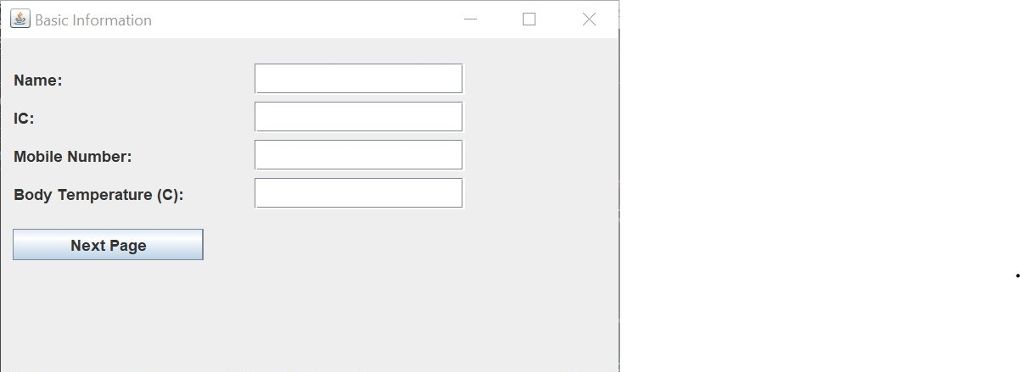

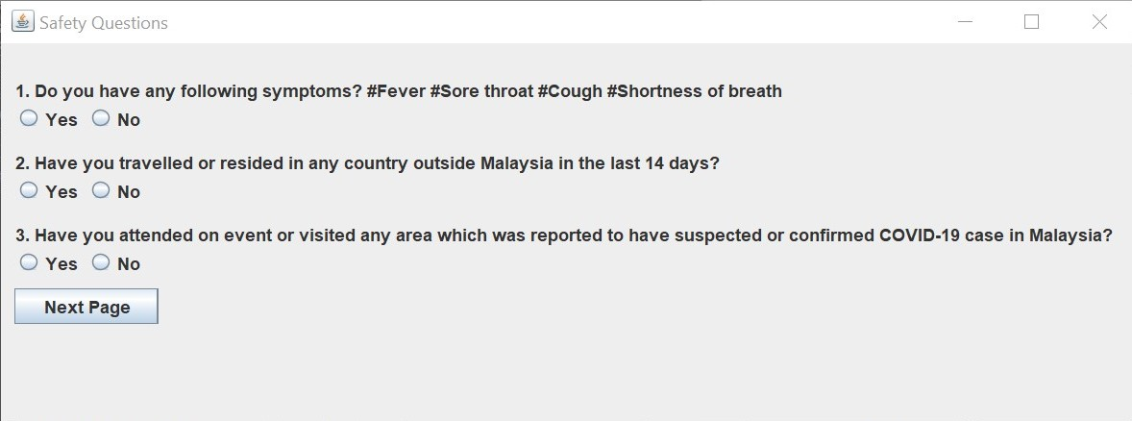

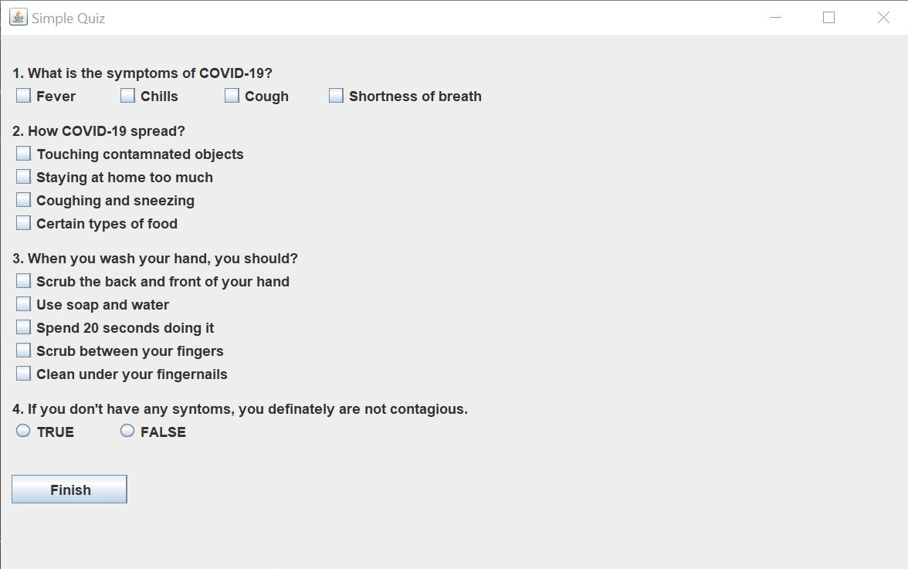

**Conclusion**

In a nutshell, although there are some problems when I write this program but in the end I manage to solve it and can run it successfully.